Title or Task: | Title  

Description:

Files Required
Suitable for Classes: | All classes
Area: | Technology & Enterprise
Teacher: | Mr Peter Faulks

Timeline

Date Due:

Task Brief:

Outcomes:

Items highlighted in yellow are tasks for you to complete
Items in Blue italics are help tips

Photoshop

APS102 Photoshop Working with text
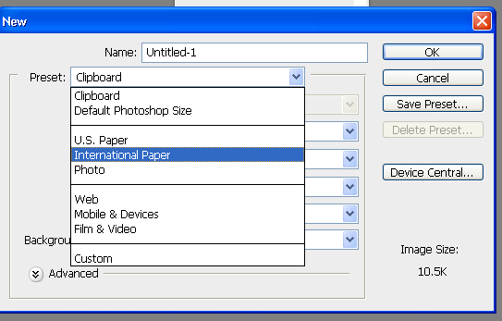
- Click on New and select A4 page 300dpi

- Click on the T text tool Type your name, then using the T Type tool drag across your text to select it.

- From the toolbar select a font and a size of 60pt
Change the colour click here

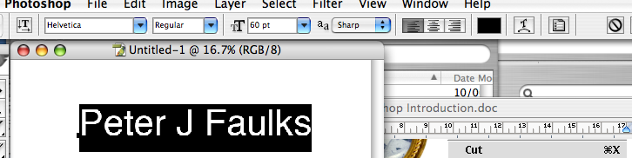

Click on Layer - Layer Style and select Bevel and Emboss (move the dialog box to one side to view text underneath)

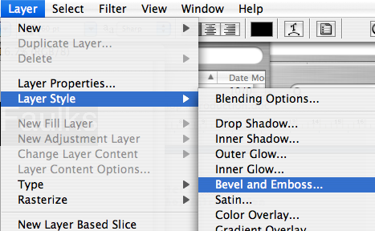

Play with the bevel controls

Add drop shadow and other layer styles to create great looking text.

Crop this and save as a name.jpg



Text Exercise
- Using fruit.jpg, add the text of your choice. Use Layers to add drop shadow or other effects and use the Warp shape tool to add a twist. i.e.

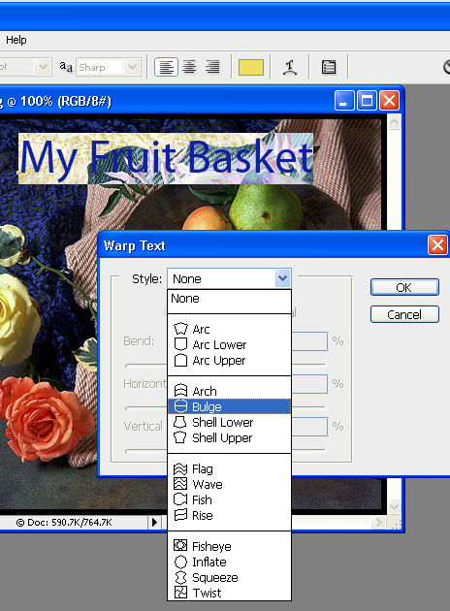
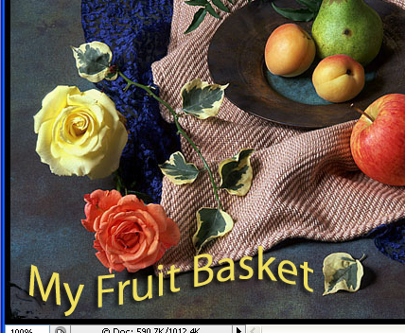

Adding effects to text
- Create some text in bold letters use the magic wand to select the text using the shift key to add each character
- Open a file with a nice image (try Cape Naturaliste1.jpg) and select all of this image (Photoshop holds this in the clipboard)
- Go back to your text which should still be selected…
- Click on Edit Paste into and paste your text into this image, move the image around using the pointer tool to get the best effect.

There are three Type tools Point (One line) Paragraph and Fit to Path

- Point is click and type
- Paragraph drag the type tool before you type (or hold down ALT)

- Type on path click the Type cursor on a pen path
- If you cannot paste into a text select the Text Tool and reset it

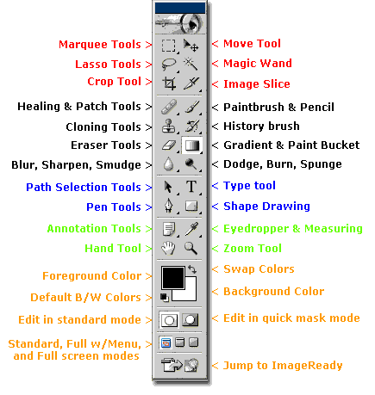

This Ends the Intro Session - Have fun with the next Session


Need help just ask

